

**PARISUTHAM INSTITUTE OF TECHNOLOGY AND SCIENCE ,THANJAVUR**

**LITERATURE SURVEY**

**IOT BASED SAFETY GADGETS FOR CHILD SAFETY MONITORING AND NOTIFICATION**

**TEAM MEMBERS:**

**SENTHILNATHAN.S(Team Leader)**

**JERAPATHISWARAN.M**

**VENKATESHWARAN.P**

**HARSHAVARATHAN**

**Paper Title :** Child Monitoring System-Tagsy.

**Authors :** Kaushik Gupta ; Mahima Sukal ; Viral Sonavadia. **Publication :** IRJMETS, April 2022, Volume:04, Issue no:04 **Methodology :** WFPS.

WFPS means Wi-Fi Positioning System. It means it does not connect to the internet but takes the

signal of the networks around it. It triangulates the signals of the network and shows us the location of the child with latitude and longitude. When a violation of child safety is identified, a certain sensor in the child module will emit a signal, which is the main function of the suggested child tracking system. These sensors and WFPS will send this signal to the microcontroller, which will then send it to the transmitter, which will then send it to the parent module. The Web application in the device will update the location of the child at an interval of 30 min, 1 hour, and 2 hours. Physical Layer consists of the sensors and the Raspberry Pi Zero. In the device the sensor is Geolocation. And the main hardware device is Raspberry Pi Zero. The connection between them is one way. Cloud will be having all the storage of the application.

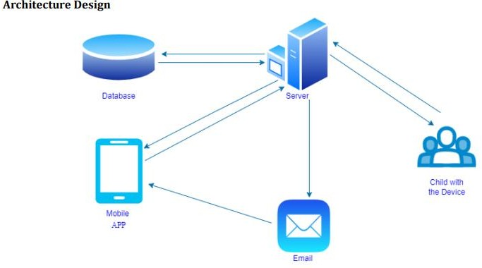

Architecture Design of the child monitoring system

LITERATURE SURVEY

**Paper Title** : Low Cost Intelligent Child Safety Wearable IoT Device for India.

**Authors** : Firoz Khan ; Yashas S ; Shivangowda R Patil ; Nandini G J ; Greeshma P S.

**Publication** : IJRTE, May 2020, Volume:09, Issue no:01

**Methodology** : MPU 6050 gyroscope.

A gyroscope is a gadget that is used to help determine orientation. This device can measure and maintain the intention and angular velocity of an object. Using MPU 6050 gyroscope and accelerometer, the present location of the children will be tracked and the voice notifications or SMS will be sent on the parent’s smartphone where the application will be installed. Node MCU microcontroller is used to process the data given by these sensors. The collect data will be stored in the firebase cloud network. The sensors, modules, buzzer are connected and programmed to observe the child’s movements and also to follow the child’s location. The application stores the last update location in firebase cloud server. Alarm buzzer is an audio signaling instrument that is either electromechanical or piezoelectric. When a child move out of zone or moves away from the parents then the parents can detect their child by the sounding loud alarm.

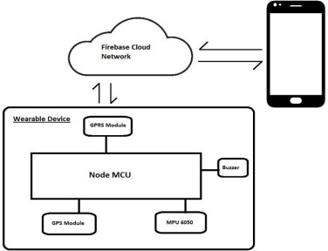

**Architecture diagram of the device**

|  |  |
| --- | --- |
| **Paper Title**: | Smart IOT Device for Child Safety and Tracking. |
| **Authors:** | M Nandini Priyanka ; S Murugan ; K N H Srinivas ; T D S  Sarveswararao ;E Kusuma Kumari |
| **Publication:** | IJITEE, June 2019, Volume:08, Issue no:08 |
| **Methodology:** | LinkIt ONE board, Sensors, Microcontroller. |

The LinkIt ONE board is an open source platform. It consists of inbuilt Wi-Fi, GSM, GPS and Bluetooth modules. The link it one board is similar to the arduino board and it is termed as all-in- one prototyping board for wearable’s and IoT devices. The board consists of ARM7 EJ-S and the clock speed is 260MHz. A SIM and SD card slots are provided on the board itself. The data is analysed using MATLAB. The audio play back module produces the recorded sound different sensors are accelerometer sensor, cry sensor, temperature sensor gas sensor, flame sensor and PIR sensor. The Pulse rate intervel is analog value from the sensor, it is converted into the beats per minute (BPM) by formulae. BPM = (1.0/Pulse Intervel) * 60.0 * 1000.

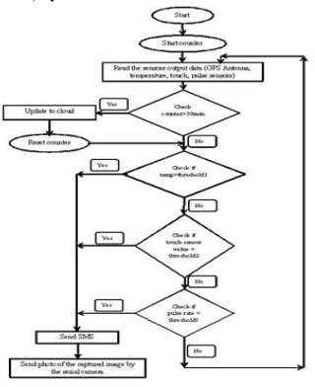

**Paper Title** : IoT Based Smart Gadget for Child Safety and Tracking. **Authors** : N. Manjunatha ; H. M. Jayashree ; N. Komal ; K. Nayana. **Publication** : IJRESM, June 2020, Volume:03, Issue no:06 **Methodology** : BEACON technology.

Boundary monitoring system is implemented on safety gadget with the help of BEACON technology, as soon as the safety gadget moves far away from the binding gadget an alert is provided to parent on binding gadget. The system is used to monitor the health parameters and also used for location tracking during necessary situations in safety concern. For measuring body temperature of the child DS18B20 temperature sensor is used. Safety gadget consists of BEACON and BLE packet is transmitted through it, this packet is received by binding gadget which has BLE (Bluetooth Low Energy) receiver module, the packet usually contains information such as identification number, signal strength etc.

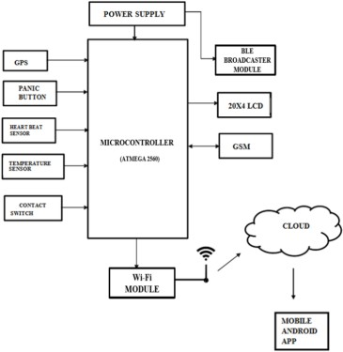

Block diagram of Smart Gadget

|  |  |
| --- | --- |
| **PaperTitle**: | SmartIOTDevice forChildSafetyandTracking. |
| **Authors:** | M Nandini Priyanka ; S Murugan ; K N H Srinivas ; T D S  Sarveswararao ;E Kusuma Kumari |
| **Publication:** | IJITEE, June 2019, Volume:08, Issue no:08 |
| **Methodology:** | LinkIt ONE board. |

The LinkIt ONE board is an open source platform. It consists of inbuilt Wi-Fi, GSM, GPS andBluetooth modules. The link it one board is similar to the arduino board and it is termed as all-in-one prototyping board for wearable’s and IoT devices. The board consists of ARM7 EJ-S and theclock speed is 260MHz. A SIM and SD card slots are provided on the board itself. The data isanalysed using MATLAB. The audio play back module produces the recorded sound differentsensors are accelerometersensor, cry sensor, temperature sensorgas sensor, flame sensorandPIR sensor. The Pulse rate intervel is analog value from the sensor, it is converted into the beatsperminute (BPM)byformulae.BPM= (1.0/PulseIntervel)*60.0*1000.

